Talking to Ben and Justin
Make bottom of chassis solid - giant sheet of carbon fiber or aluminum
Back half aluminium

Need
-foot break
-back break needs new spring (3 of them)

-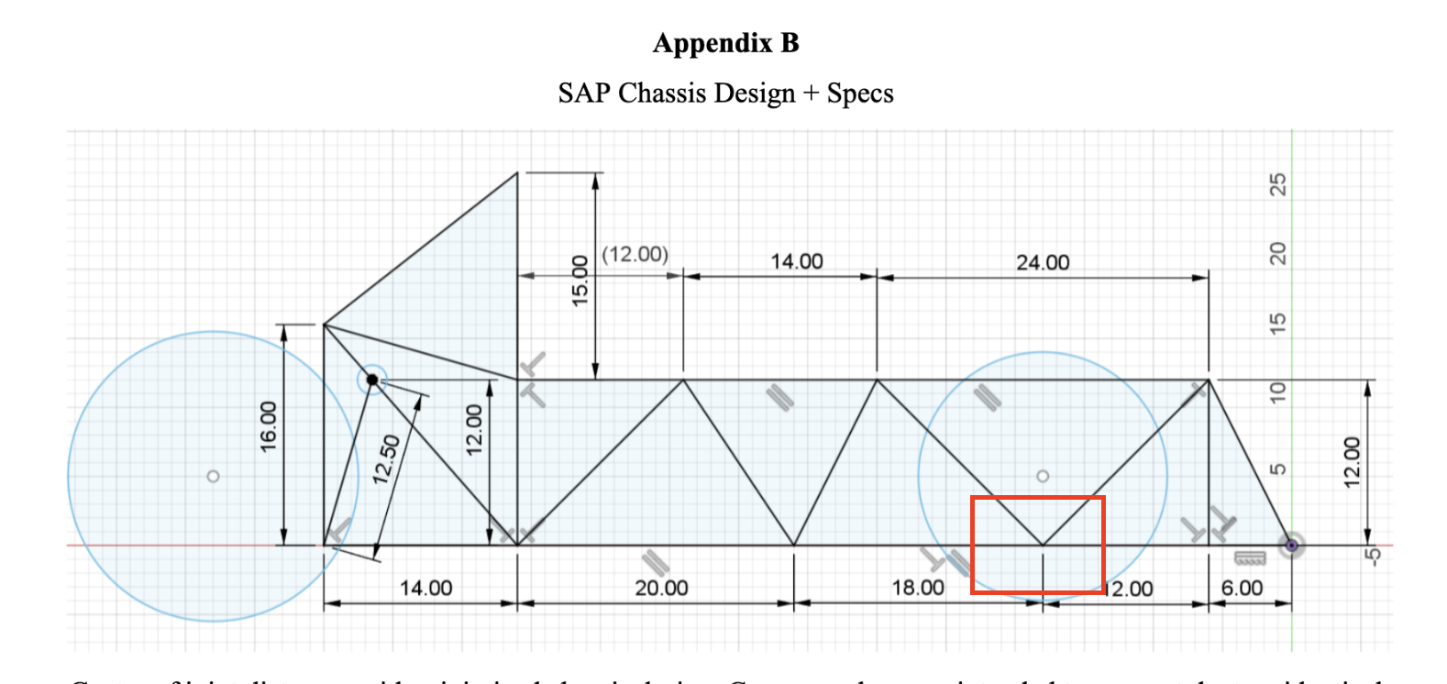
Red box make aluminum joint and not 3D print

-tubes take a week

-mcmastercar 2 days max

-build simulation of front
-carbon fibre middle
-aluminum frame so that
-utm (ask carr/fiona)

Find diameter of wheels
Find how suspension connects onto the vehicle
Redesign front half to have suspension connect
- Most go-karts have suspension attached to one vertical member
- 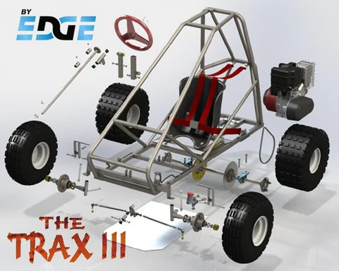

Steps to use markforged
0. Login to computer 2
- Use a program called eiger.io
  - Pretend to be josh
- Export what you want to be printed in an STL file
- Import into eiger ur stl file
- Have threads on z axis
- Material is onyx
  - No reinforcement necessary unless shape is wonky
- Export Build
- Put that file onto flashdrive
- Stick drive into printer
- Hit print from storage

Look into villanova sae

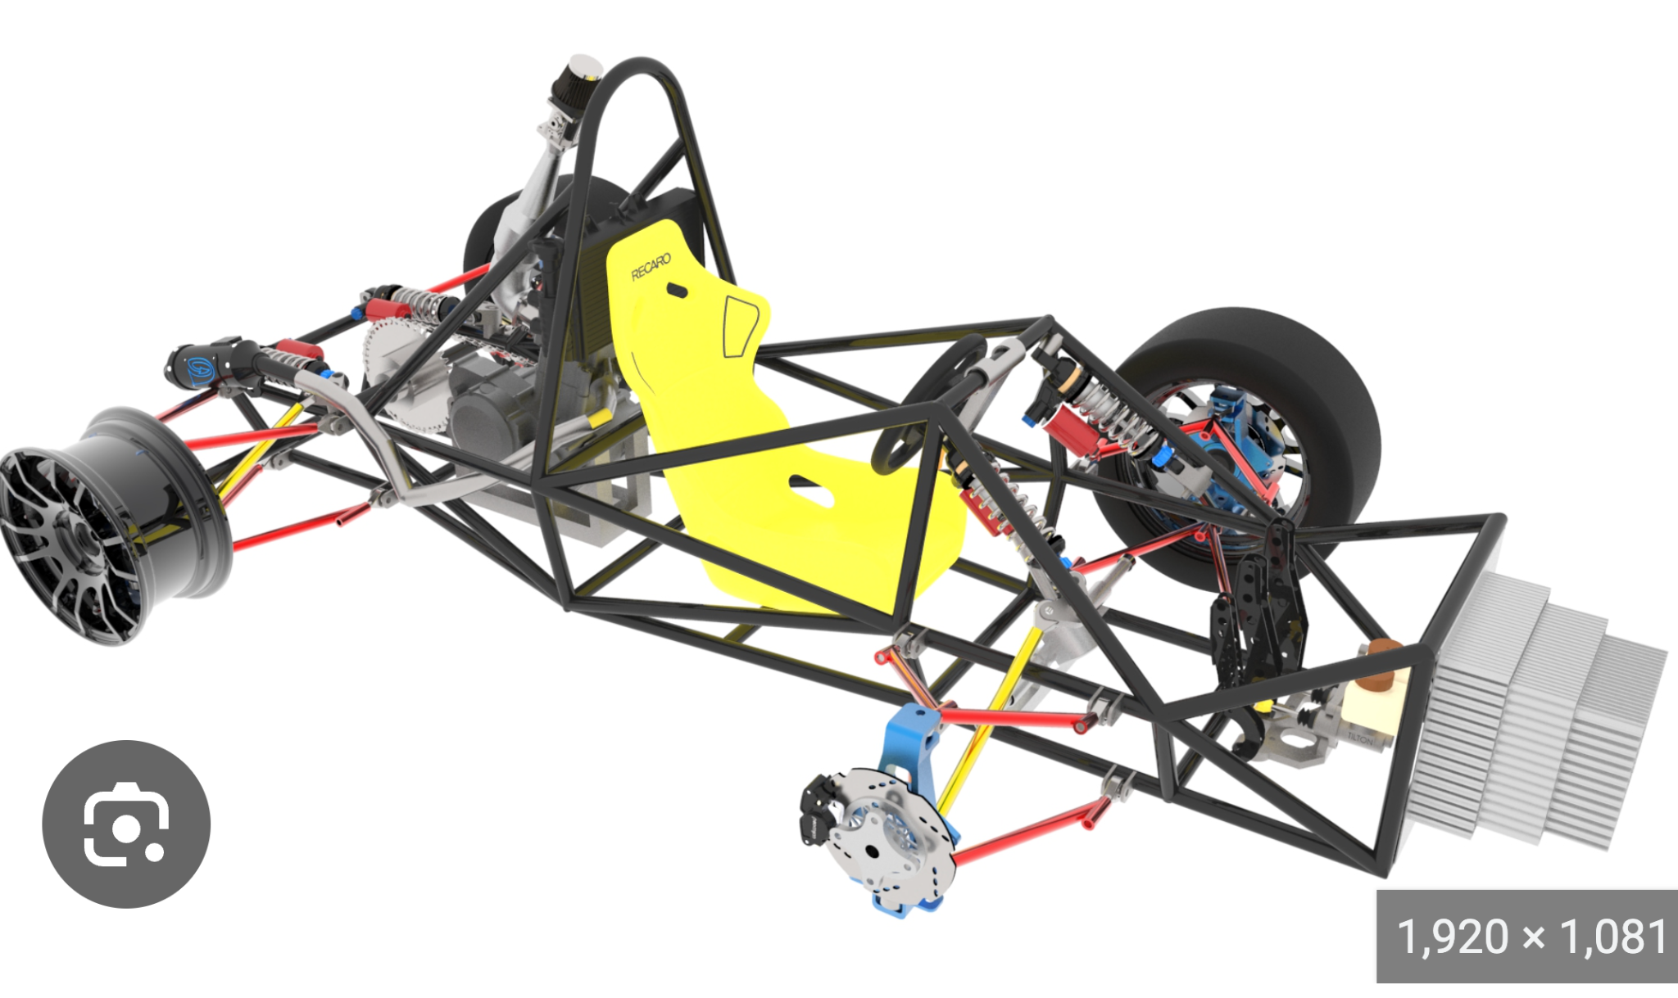
https://abhijeetscad.wordpress.com/2015/01/03/fsae-car/

Look into buying a…
- Gear and pinion steering system
  - https://www.amazon.com/dp/B0BBLRNKTD/ref=sspa_dk_hqp_detail_aax_0?psc=1&sp_csd=d2lkZ2V0TmFtZT1zcF9ocXBfc2hhcmVk
- Suspension system
  - https://www.amazon.com/s?k=go+kart+front+suspension+kit&ref=nb_sb_noss

- Pivot point for wheels
- Hydraulic disk brakes
- Wheels
  - $450 https://www.trikexplor.com/products/20inch-completed-wheels-with-disc-brakes
  - $150
  - Aliexpress

- Large piece of clear plastic for bottom trough

Progress Report for Carr
- Have learned necessary fabrication techniques
  - Welding
  - 3D print
  - Lathe
- Have started considering parts we want
  - Suspension and steering ordered
  - Wheel size and disk brake for the front wheels
  - Brakes?
- Very rough rudimentary design
- Working on powerpoint

Final Report Notes

Goals - Redesign and fabricate front half of HFCV Chassis
Methods - Utilized E90 Research
Results - Have part of the frame completed
Significance - prepares for the fall semester and future E90s

